Isaiah Bryant
CS 320
Project Two
10/16/2026
Professor Norman

Summary
The contact object has five rules: a unique ID that is not null, not longer than 10 characters, and not updatable; a first and last name that are not null and not longer than 10; a phone number that is not null and exactly 10 digits; and an address that is not null and not longer than 30. The service must add only unique IDs, delete by ID, and update first name, last name, phone, and address by ID. Contact and ContactService enforce those rules, and the test files check that both classes follow them. The task requirements are the same shape with different limits: a unique task ID that is not null, not longer than 10, and not updatable; a name that is required and not longer than 20; and a description that is required and not longer than 50. The service must add with a unique ID, delete by ID, and update name and description by ID. The appointment service is even simpler but with a new requirement, the appointment must not be in the past. The appointment service must be able to add by unique ID and set an appointment date not in the past. This introduced a date function into the testing. My testing approach was to write the requirements out, then build the tests from those requirements. For the contact name rules, the setters reject null and a length greater than 10, and the service updates call those setters. The tests pass null, edge cases, and invalid values and check that each one either fails as expected or is stored. I used the same pattern for the other variable requirements in task, contact, and appointment packages. All test behaved as expected with 100 percent coverage.
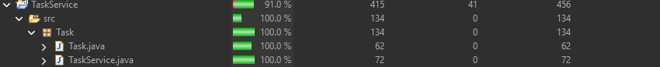
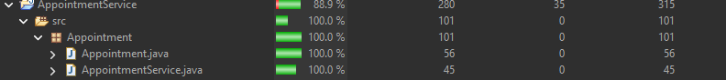

To make sure the code was technically sound, I tested as I wrote it. I would finish a method, run the test for that method, and check that the line did what I expected before I moved on. After each class was finished I read back through it. Fields that should not be changed from outside the class are private, and the IDs are private and final so there is no setter for them. I also used assert throws for the failing cases instead of checking a message string. The requirement is that bad input is rejected, so the test only passes if the method throws.
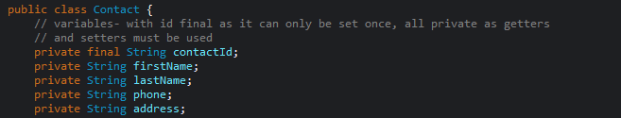
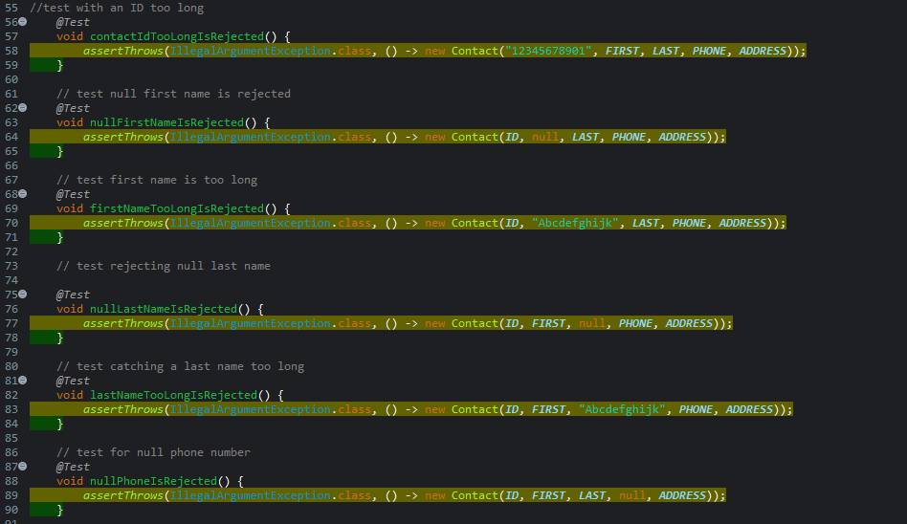
To keep the tests efficient, I wrote them so I could reuse most of the setup and only change what the requirements ask for from contact to task service. I used parameterized test and CsvSource let me put the bad constructor cases in one method, invalidTaskIsRejected, instead of a separate test for each one. The update tests do the same thing with NullSource and ValueSource. 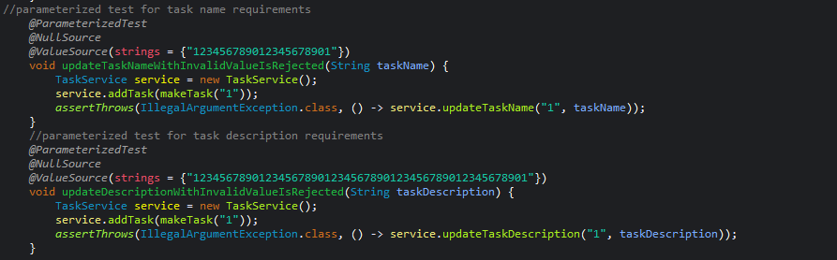
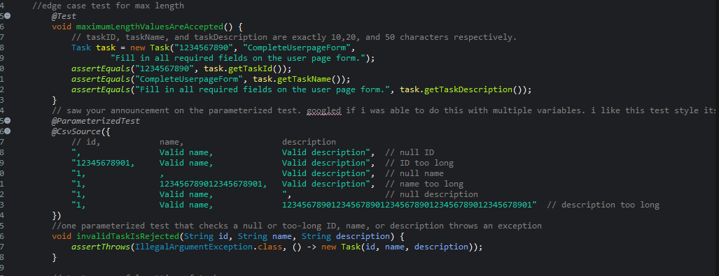
Reflection
I used several testing techniques across the three assignments. Unit testing was the main one. I wrote a test for a method and checked that the method did what the requirement said. The task delete is a simple example. DeleteTaskRemoves It adds a task, deletes it, and then checks that it is gone.
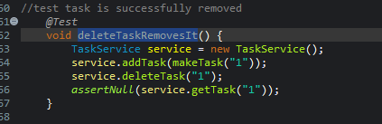
If delete looked like it ran but left the task in the map, that test would fail. I also used static testing, which is reviewing the code without running it. After I finished a method, and again after I finished a class, I read back through it and checked that fields which should not be changed were private, and that the IDs were final. I also used boundary testing. I check to ensure that 50 char worked in the task description but not 51 in the task test.
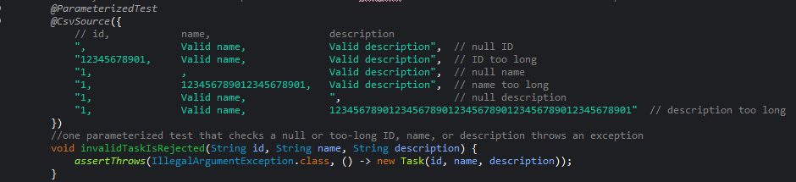
I did not use integration testing, system testing, or regression testing. Integration testing checks that separate pieces work together, like the service talking to a database. Mine only stores objects in a HashMap, so the tests never leave the class. System testing runs the whole application the way a user would. These milestones had no screens or full workflow. Regression testing means keeping the old tests and rerunning them after a later change to make sure the old rules still pass.
Unit testing fits a project where each requirement is one method or small requirements like the three assignments. Static testing checks for structure a running test could miss, such as making sure the contact ID and task ID stayed private and final or as was pointed out to me making a method final if it is called from a constructor. Boundary testing fits a rule with a cutoff, such as a task description of 50 characters passing and 51 throwing. Integration testing fits once a class must work with something outside itself, like a service saving to a database. System testing fits when there is a full user flow and a screen. Regression testing fits a longer project, where the old milestone tests get rerun after a later change so a rule that already passed does not break.
Acting as the software tester, my approach was to think of the ways I could possibly break the program and then incorporate checks against the most relevant possibilities to ensure that no one else could exploit those weaknesses. In this case, “most relevant” meant the most likely or most damaging defects. It is impossible to prevent every defect or every possible escape, so as testers we should focus on preventing the most probable or most damaging ones. As the tester of these applications, I took precautions to ensure the requirements were met by testing several approaches to breaking them, including edge cases. It was important to appreciate the complexities and interrelationships of the code because the services do not contain the validation checks themselves. These checks are held in the Appointment, Task, and Contact classes. Understanding these interrelationships helped when writing the tests and knowing when and why an exception would be thrown. For instance, when updating a first name, the ContactService update method only finds the contact and then calls the setter method on the Contact object to actually perform the update.
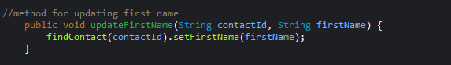
Eliminating bias as both the developer and the tester can be difficult because of creator bias. As the creators of our code, we are like Frankenstein and may choose not to see our creation as the monster it may actually be. An example was the mistake of not marking a method as final when it was called from the constructor. I submitted the code thinking it was solid, but assignment feedback pointed out that I had overlooked a normal coding practice. When coding I did my best in eliminating bias by conducting several static reviews even when I had accepted my code as complete, I reviewed the code as if something were missing and I had yet to find out what.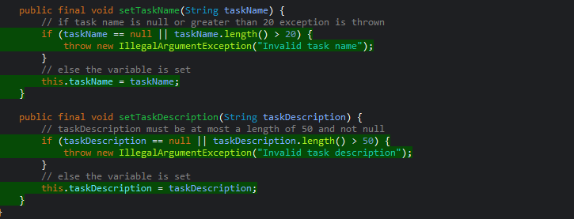
It is important for a developer to commit to the quality of code because of the nature of cost, which is illustrated in Boehm’s Cost-of-Change curve. The later in the SDLC an error is found, the more resources will be required to correct the bug. In addition to financial and resource loss, once customer trust is lost it is harder to regain. While this highlights the discipline required of a software engineer in ensuring quality, developers may feel concerned that the extra time needed to produce quality code will create technical debt. This is the reason I performed boundary testing in my code ensuring that the exact requirements were met. 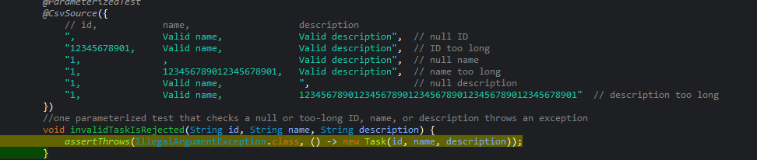Developers should rest assured that focusing on quality actually saves them from even more technical debt that a later rework could add. To avoid technical debt, I will focus on quality to prevent rework and concentrate on code that is of consequence. Focusing on code of consequence helps ensure a developer is addressing actual requirements rather than working on a piece of code that would not benefit the project.

